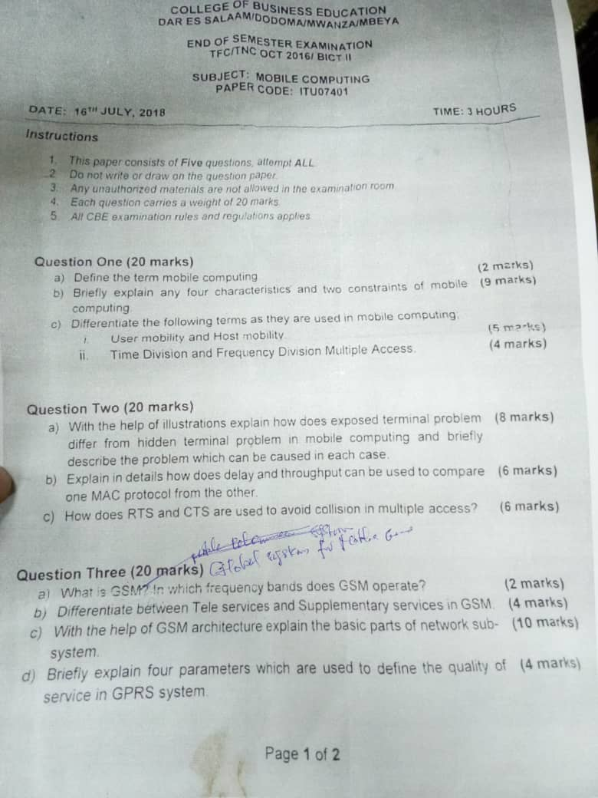
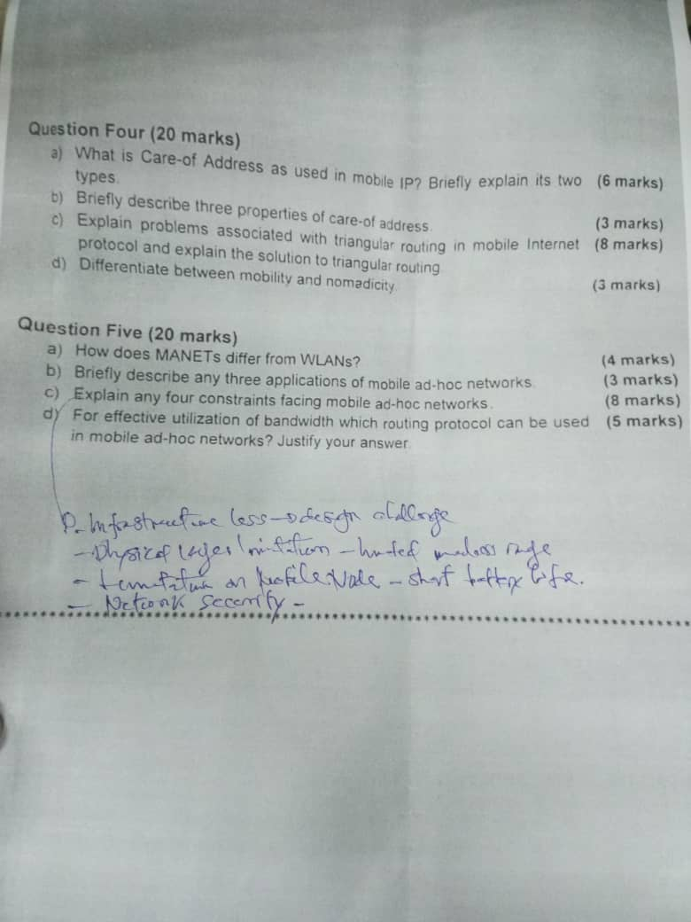

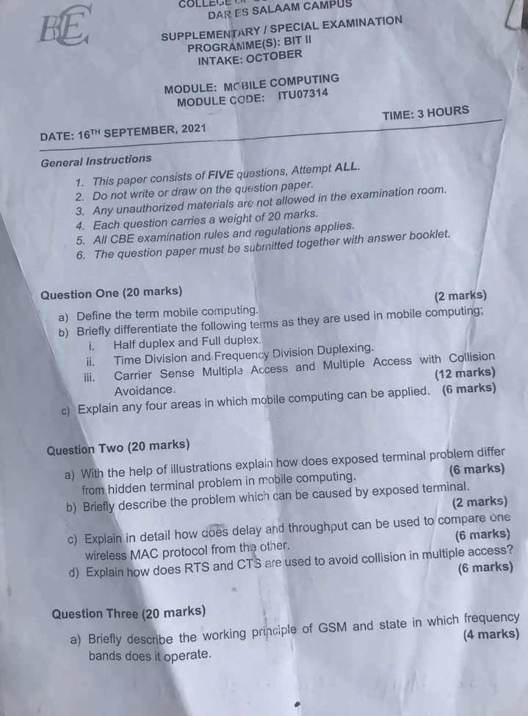
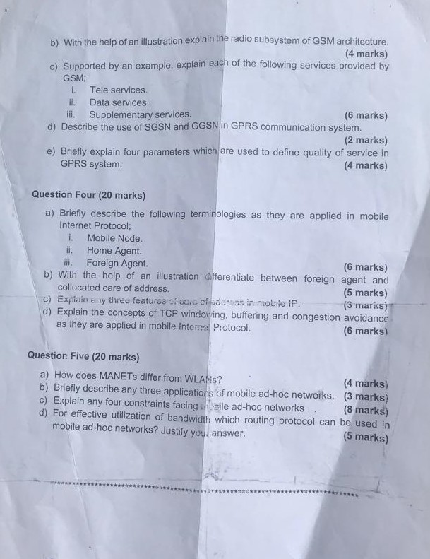

3G NETWORK
3G refers to the third generation of cellular technology that enables mobile telephony To connect to a 3G service, a user has to subscribe to a provider where typically you pay regularly for a set amount of data transfer allowance
Technology under 3G include UMTS which include W-CDMA and HSPA another is CDMA2000
3G ARCHITECTURE
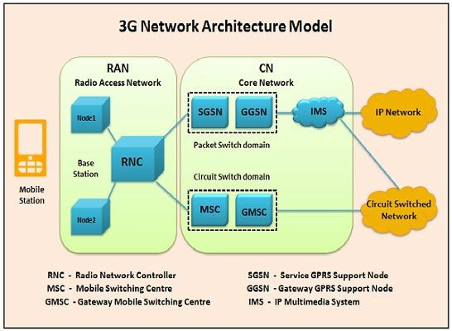
How 3G works
UMTS (Universal Mobile Telecommunications System) . UMTS, short for Universal Mobile Telecommunications System, is a 3G networking standard used throughout much of the world as an upgrade to existing GSM module.
UMTS makes use of WCDMA, a technology that shares much with CDMA networks used throughout the world, though it is not compatible with them. Base level UMTS networks are generally capable of downlink speeds as 384 kbps. The UMTS architecture takes advantage of the existing GSM and GPRS networks which serve as a core network in UMTS infrastructure.
The UMTS is made up of 3 main components:
a) User Equipment:
It is assigned to a single user and contains all the functions needed to access UMTS services. It contains Mobile Equipment (ME) With SIM card It is a radio terminal which is used to connect the UMTS subscriber with the fixed part of UMTS system via the radio interface. UMTS Subscriber Identity Module (USIM): A smartcard which contains the subscriber identity, authentication algorithms, encryption keys etc.
b) UMTS Terrestrial Radio Access Network (UTRAN):
It handles cell-level mobility. It is a system of base station and controller handling function related to mobility. It contains:
1. Nodes B (Base Stations): It converts the data between Uu radio interface and the Iub interface connecting a Node B with the RNC. • It performs physical level processing such as channel coding, data interleaving, rate matching, modulation etc.
2. Radio Network Controllers (RNC): RNC’s controls and manages radio resources to Node B. • RNC performs the data-link layer processing and participates in handover operations. • RNC is considered a single access point of UTRAN for the core network. • It’s connected to a single MSC/VLR to route circuit-switched traffic and to a single SGSN to route packet switched traffic.
c) Core Network (CN):
The core network is shared with GSM and GPRS. The CN contains functions for intersystem handover, gateways to other networks and performs location management. It contains:
- Home Location Register (HLR)
- Mobile Station Controller / Visitor Location Register (MSC/VLR).
- Gateway MSC: Connect UMTS to external circuit switch n/w (e.g. PSTN)
- Serving GPRS Support Node (SGSN): It serves the Packet-switched traffic.
- Gateway GPRS Support Node (GGSN): Connects UMTS to external packet switched. (e.g. Internet)
Application of 3G
- Mobile Multimedia Messaging Service MMS is a multimedia communication mode based on the store-and-forward mechanism. Different from SMS and EMS, MMS has no restriction on the amount and complexity of information contents. So MMS can be used to transmit short messages in texts, as well as pictures, videos and audios
- Streaming Media It support playing high-quality audio and video programs online at the speeds of from 28 kb/s to 1 200 kb/s. As a typical 3G service, streaming media represent animated images and information services.
- Open Service Architecture Provide open service platform for rapid service deployment. third party have a chance to provide services. It has advantages in network interworking and in the rapid deployment standard and uniform network Application Program Interface (API), which allows the third party to effectively upload services.

4G NETWORK
What done on 4G is a system architecture revolution, doesn’t mean the upgrading from 3G to 4G but means the design of new architecture for the purpose of high mobility of network, let’s look on the following important elements in 4G network
Control plane used to exchange signaling message in order to control UE
User plane used to exchange user data, these both processes are done on different elements in 4g network during data transmission let’s look on its architecture
4G NETWOR ARCHITECTURE
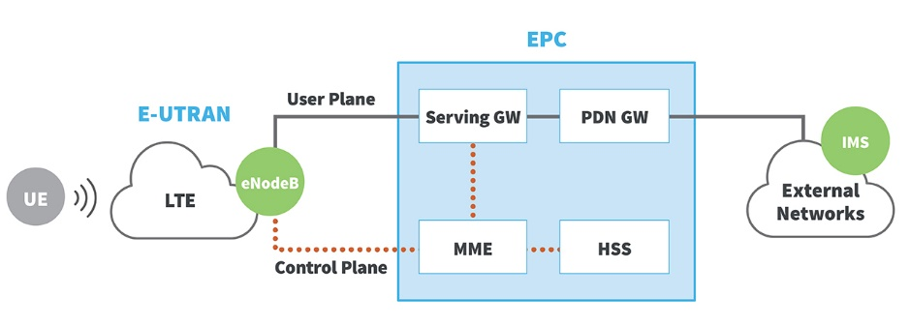
HOW IT WORKS
In E-UTRUN (Evolved UMTS Terrestrial Radio Access Network) it contains nodes which is basically transmitter and receiver which communicates with device through Radio waves in 4g network this work as independent element hence it doesn’t wait any permission from controller
During starting a session MME Make signaling communication with eNode and serving GW to control Data transmission from UE also MME deals with authorization and user authentication
While HSS store all information from the UE
Data are transferred from eNode to serving getaway SGW to eliminate any effect from user shifting from one node to another in E-UTRUN
Lastly PND GW is connected to the external network
APPLICATION OF 4G
4G Data intensive interactive user services - Services such as online satellite mapping will load instantly.
4G Multiple User Video conferencing - subscribers can see as well as talk to more than one person.
4G Location-based services - a provider sends wide spread, real time weather or traffic conditions to the computer or phone, or allows the subscriber to find and view nearby businesses or friends whilst communicating with them.
4G Tele-medicine - a medical provider monitors or provides advice to the potentially isolated subscriber whilst also streaming to them related videos and guides.
4G HDTV - a provider redirects a high definition TV channel directly to the subscriber where it can be watched.

5G NETWORK
Like other cellular networks, 5G networks use a system of cell sites that divide their territory into sectors and send encoded data through radio waves. Each cell site must be connected to a network backbone, whether through a wired or wireless backhaul connection. 5G networks use a type of encoding called OFDM, which is similar to the encoding that 4G LTE uses. The air interface is designed for much lower latency and greater flexibility than LTE, though.
5G ARCHITECTURE
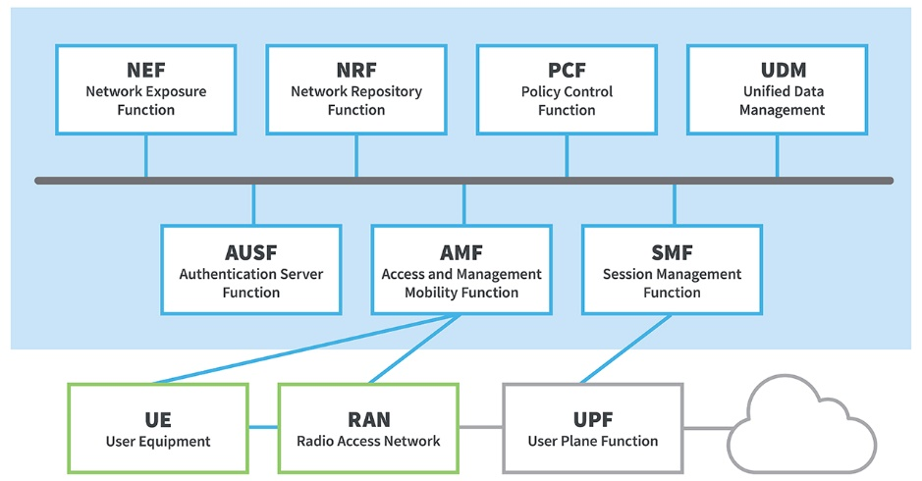
User Equipment (UE) like 5G smartphones or 5G cellular devices connect over the 5G New Radio Access Network to the 5G core and further to Data Networks (DN), like the Internet.
The Access and Mobility Management Function (AMF) acts as a single-entry point for the UE connection. Based on the service requested by the UE, the AMF selects the respective Session Management Function (SMF) for managing the user session.
The User Plane Function (UPF) transports the IP data traffic (user plane) between the User Equipment (UE) and the external networks.
The Authentication Server Function (AUSF) allows the AMF to authenticate the UE and access services of the 5G core.
Other functions like the Session Management Function (SMF), the Policy Control Function (PCF), the Application Function (AF) and the Unified Data Management (UDM) function provide the policy control framework, applying policy decisions and accessing subscription information, to govern the network behavior.5G network architecture is more complex behind the scenes, but this complexity is needed to provide better service that can be tailored to the broad range of 5G use cases
APPLICATION OF 5G

Autonomous Vehicles
Autonomous vehicles are one of the most anticipated 5G applications. Vehicle technology is advancing rapidly to support the autonomous vehicle future. Onboard computer systems are evolving with levels of compute power previously only seen in data centers.

5G IoT in Smart City Infrastructure and Traffic Management
Many cities around the world today are deploying intelligent transportation systems (ITS), and are planning to support connected vehicle technology. Aspects of these systems are relatively easy to install using current communications systems that support smart traffic management to handle vehicle congestion and route emergency vehicles

Applications in Industrial Automation
The key benefits of 5G in the industrial automation space are wireless flexibility, reduced costs and the viability of applications that are not possible with current wireless technology. Industrial automation is in use today, and most likely you have seen videos showing synchronized robotics at work in factories and supply chain applications

ANSWERS
Question 1 (a)
Mobile Computing is a technology that allows transmission of data, voice and video via a computer or any other wireless enabled device without having to be connected to a fixed physical link.
(b)
User Mobility: – User should be able to move from one physical location to another location and use the same service. Example could be a user moves from London to New York and uses Internet to access the corporate application the same way the user uses in the home office.
Network Mobility: – User should be able to move from one network to another network and use the same service. Example could be a user moves from Hong Kong to New Delhi and uses the same GSM phone to access the corporate application through WAP (Wireless Application Protocol). In home network he uses this service over GPRS (General Packet Radio Service) whereas in Delhi he accesses it over the GSM network.
Bearer Mobility: – User should be able to move from one bearer to another and use the same service. Example could be a user was using a service through WAP bearer in his home network in Bangalore. He moves to Coimbatore, where WAP is not supported, he switch over to voice or SMS(Short Message Service) bearer to access the same application.
Device Mobility: – User should be able to move from one device to another and use the same service. Example could be sales representatives using their desktop computer in home office. During the day while they are on the street they would like to use their Palmtop to access the application.
Constraints
• Limited ressources
• Variable connectivty:
– Performance
– Reliability

(c) - i
User mobility-User should be able to move from one physical location to another location and use the same service.
-The service could be in the home network or a remote network
Host mobility- The user device can be either a client or server.
-When it is a server or host, some of the complexities change.
– In case of host mobility the mobility of IP needs to be taken care of.
-ii
FDMA | TDMA
FDMA stands for frequency division multiple acces | TDMA Stands for time division multiple access
Overall bandwidth is shared among number of station | Time sharing of satellite transponder takes place
Guard bands between adjucent channels is neccessary | Guard time between adjucent slots is necessary
Synchronization is not required | Synchronization is reuired
Power efficiency is less | Power efficiency is high
It requires stability of high carrier efficiency | It does not requires stability of high carrier efficiency
Its basically used in GSM and PDC | its basically used in advanced mobile phone

Question 2 (a)
Hidden Terminal Problem | Exposed Terminal Problem
A sends to B, C cannot receive A | B sends to A, C wants to send to D
C wants to send to B, C senses a “free” medium (CS fails) | C has to wait, CS signals a medium in use
collision at B, A cannot receive the collision (CD fails) | since A is outside the radio range of C waiting is not necessary
A is “hidden” for C | C is “exposed” to B
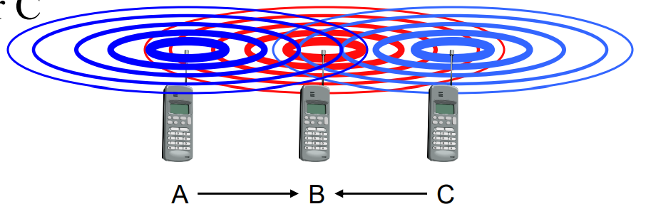 | 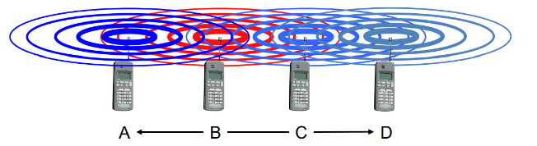
Problem which caused in each

Solution in hidden terminal problem
Increase Transmitting Power from the Nodes
Use Omni directional antennas
Remove obstacles
Move the node
Use protocol enhancement software
Solution in exposed terminal problem
MAC (medium access control) layer protocol IEEE 802.11 RTS/CTS
(b)
Delay
Defined as the average time spent by a packet in the MAC queue, i.e. from the instant it is enqueued till its transmission is complete
Sensitive to traffic characteristics, so two MAC protocols should be compared under identical traffic conditions
- Throughput
Fraction of channel capacity used for data transmissions
MAC need to maximize throughput while keeping the access delay to minimum
(c)
Use signalling packets to avoid collision.
RTS (Request to send)
Sender request the right to send from a receiver with a short RTS packet before it sends a data packet.
CTS (Clear to send)
Receiver grants the right to send as soon as it is ready to receive
Question 3 (a)
GSM (Global System for Mobile communication) is a digital mobile telephony system that is widely used in Europe and other parts of the world. It operates at either the 900 MHz or 1800 MHz frequency band
(b)
TELE SERVICES: Includes mobile phones, emergency calling etc.
SUPPLYMENTARY SERVICES: I/C & O/G calls, call forwarding, call hold, call waiting, conference, etc.
Teleservices
The abilities of a Bearer Service are used by a Teleservice to transport data. These services are further transited in the following ways -Voice Calls, Videotext and Facsmile, Short Text Messages
Supplementary services
are additional services that are provided in addition to teleservices and bearer services. These services include caller identification, call forwarding, call waiting, multi-party conversations, and barring of outgoing (international) calls, among others.

(c)
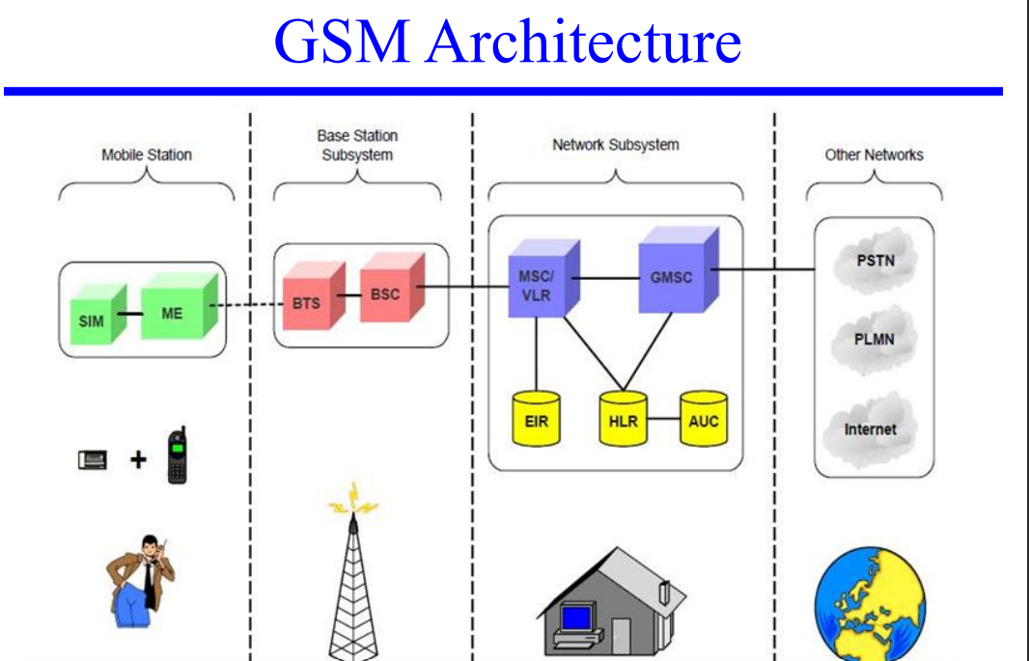
Home location register (HLR) —The HLR is a database used for storage and management of subscriptions.
Mobile services switching center (MSC) —The MSC performs the telephony switching functions of the system.
Visitor location register (VLR) —The VLR is a database that contains temporary information about subscribers that is needed by the MSC in order to service visiting subscribers.
Authentication center (AUC) —A unit called the AUC provides authentication and encryption parameters that verify the user's identity and ensure the confidentiality of each call.
Equipment identity register (EIR) —The EIR is a database that contains information about the identity of mobile equipment that prevents calls from stolen, unauthorized, or defective mobile stations.
(d)
The service precedence is the priority : high, normal, and low.
The reliability indicates the transmission characteristics required by an application. Three reliability classes are defined, which guarantee certain maximum values for the probability of loss, duplication, missequencing, and corruption (an undetected error) of packets
The delay parameters define maximum values for the mean delay. The delay is defined as the end-to-end transfer time between two communicating mobile stations or between a mobile station and the Gi interface to an external packet data network.
The throughput specifies the maximum bit rate and the mean bit rate.
Question 4 (a)
Care-of Address (COA) – is a temporary IP address for a mobile device used in internet routing .this allows a home agent to forward messages to the mobile devices
-can be chosen, e.g., via DHCP

Types of COA
A foreign agent care-of address is an IP address of a foreign agent which has an interface on the foreign link being visited by a mobile node. Can be shared by many mobile nodes simultaneously
A collocated care-of address is an IP address temporarily assigned to an interface of the mobile node itself.
(b)
Properties of COA
- A care-of address is specific to the foreign link currently being visited by a mobile node
- Generally changes every time the mobile node moves from one foreign link to another
- No Mobile IP-specific procedures are needed in order to deliver packets to a care-of address θIs used as the exit-point of a tunnel from the home agent toward the mobile node
- Is never returned by DNS when another node looks up the mobile node’s hostname
(C)
Problems in triangular routing
- Firewalls at the foreign network may not allow that
- Multicasting: if a MN is to participate in a multicast group, it needs to use a reverse tunnel to maintain its association with the home network.
- TTL: a MN might have a TTL that is suitable for communication when it is in its HM.
Solution
- reverse tunneling
(d)
Nomadic Computing: The computing environment is nomadic and moves along with the mobile user.
• This is true for both local and remote services.
Mobility: The capability of move from one point to another.

mobility as the physical movement of people between locations

the ability to access platforms and compute data from various types of devices

Question 5 (a)
WLAN is a type of local-area network that uses high-frequency radio waves rather than wires to communicate between nodes. A mobile ad hoc network (MANET), sometimes called a mobile mesh network, is a self-configuring network of mobile devices connected by wireless links
(b)
- Tactical networks
Military communication, automated battlefields
- Emergency Services
Search and rescue operations
Disaster recovery – Earthquakes, hurricanes .
- Educational
Virtual classrooms or conference rooms.
Set up ad hoc communication during conferences, meeting, or lectures
- Home and Entertainment
Home/office wireless networking.
Personal Area network
Multiuser games
Outdoor internet access.
(c)
- Infrastructure less
Brings new network designing challenges.
- Dynamically changing topologies
Cause route changes, frequent network partitions and packet loss.
  - Physical layer limitations
Limited Wireless range.
Packet loss during transmission.
Broadcast nature of the communication.
  - Limitations of Mobile Nodes
Short battery life
Limited capacities.
  - Network security
(d)

